**Remove all links to Social Engine content:**

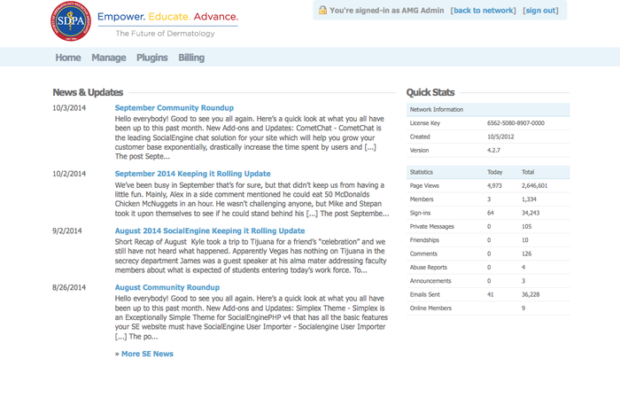

**Remove “See KB article” links to Social Engine content:**

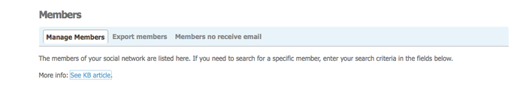

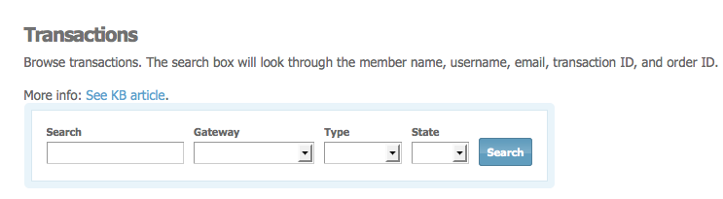

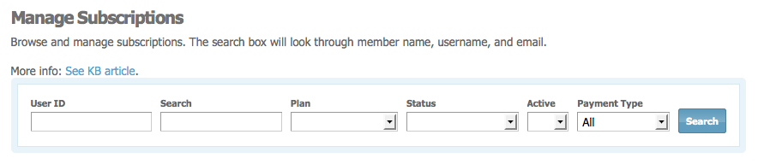

**Remove all plugins except DLI:**

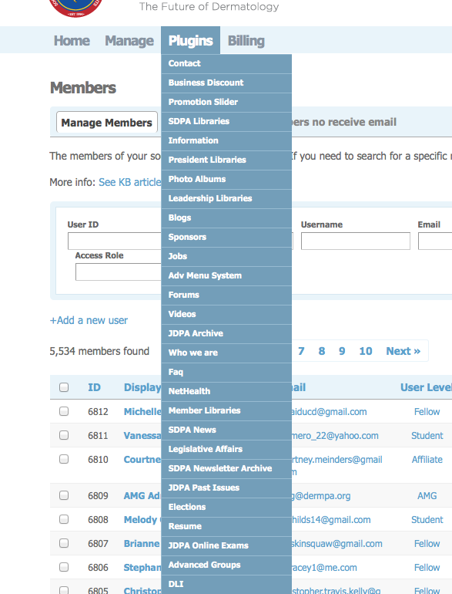

**Should SDPA Admin or Email be accessible?**

